cd..

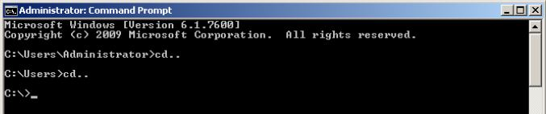

dir

cd

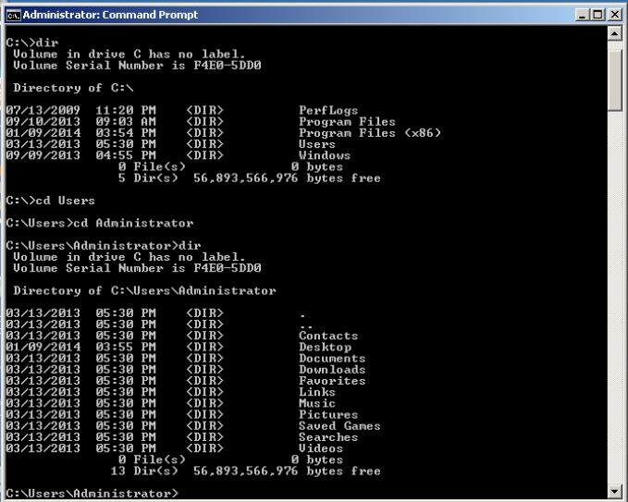

md

rd

copy

del

move

Remote move

